Courier Management System

## Project

## Submitted By

Vaibhav Singh

Reg.No.: 18BCE2257

Deep Agrawal

Reg.No.: 18BCE0518

Shubham Agrawal

Reg.No.: 18BCE0542

Sparsh Hurkat

Reg.No.: 18BSW0028

Guided By –

Prof. Navamani TM

CSE2004 – Database Management Systems

B.Tech. (Branch) – II Year

SCOPE



## VELLORE INSTITUTE OF TECHNOLOGY

## VELLORE – 632014

TAMIL NADU INDIA

Date:06–10–2019

1. **Abstract**

Courier Management System is a web-based courier system which supports the high accessibility of courier services to the companies and to the customers. This system is being used for day to day activities such as booking a courier, maintain customer details, track the parcel.

People when transfer their products using any courier service wants to know whether their product has been safely parceled to their right place or not, if not then by what time it will be delivered and what is the exact location of the product. Tracking all this information manually is very difficult and time taking process. To minimize these complexities, we require some system which can track the parcel on time basis.

Courier Management System is a web-based courier system which supports the high accessibility of courier services to the companies and to the customers. This system is being used for day to day activities such as booking a courier, maintain customer details, track the parcel. The Classic approach of courier industry leads to many misleading outcomes and very slow output from the industry. So, we tend to improve and bring a new change for this 1 trillion $ industry around the Globe.

1. **Introduction**

The Courier Management System Project have different modules. The login section will have login facility for the admin who will operate this system. While taking orders from its customers, it will take all the details of its customers who is placing the order and all the details for the recipient such as its address, name, mobile number. During billing process system will generate a tracking id or consignment number for their products. Using this consignment number, customers or its recipient will able to track their products from any location using internet. It will provide tracking status of the product after placing order.

Companies that deliver parcel were disadvantage in that they had to keep all information of parcel there are delivering on paper and also they spent a lot trying to get the person who will receive the parcel by calling them which cost a lot of money to the company but by use of this system it will get rid of paper work and also the information of what was being delivered will be kept for future reference which will make easier and convenient when it is being searched and furthermore client will be able to get a forehand information about their parcel on what time they will receive so that they will plan and by doing this it will enable the customers to have confidence on what is being offered in the company thus leading to higher returns to the company the to the paper work.

The **purpose** of the proposed system is to help customers to keep track of their shipments anytime, anywhere using the courier website. Also creating the accounts for courier officers allows us to keep the database secure as only the authorized can access the database. The proposed system is a light weight courier system built entirely using php and frontend languages for smooth and better user experience.

**Motivation** *–*

These days all the data is store in the database. But few departments still make use of traditional way of storing shipment details using paper and pen (forms). This system allows us to take advantage of the technology and hence making managing database much more efficient and easier.

People when transfer their products using any parcel service wants to know whether their product has been shifted to their right place or not, if not then by what time it will be shifted and where itis now. Taking all this information manually is very difficult and time taking process. To handle all these activities, include various processes and paper work from the management side also.

**Problem Statement –**

People when transfer their products using any courier service wants to know whether their product has been shifted to their right place or not, if not then by what time it will be shifted and where it is now. Taking all this information manually is very difficult and time taking process. To handle all these activities, include various processes and paper work from the management side also.

Tracking all this information manually is very difficult and time taking process. To minimize these complexities, we require some system which can track the parcel on time basis.

1. **Literature Survey**

|  |  |  |  |  |  |  |  |
| --- | --- | --- | --- | --- | --- | --- | --- |
|  | Research paper | Author | Year of Publication | Method used | Drawbacks | | Advantages |
| 1 | High performance PL/SQL programming | Vamsi Krishna Myalapalli ;  BhupatiLohith Ravi Teja | 2017,  IEEE | reduce time and space complexity of a native SQL query | * Longer queries * Difficult to understand * Low usability | | Faster than regular queries applied in today databases |
| 2 | DBMS as a Cloud service: Advantages and Disadvantages | YlberJanuzaja ,JauminAjdaria , BesnikSelimia | 2018  Science Direct journal | Website hosting on cloud instance | * Websites are slower to access * If cloud fails then website stop * costly | | * Can be accessed from any device * Portable |
| 3 | An Appraisal to Optimize SQL Queries | Vamsi Krishna Myalapalli, MudduButchi Shiva | 2017  IEEE | Using PL/SQL and oracle for increasing the speed of queries | Complex system required to build the final outcome database | | Faster than the regular DBMS techniques |
| 4 | An Overview of Query Optimization Techniques in Database Systems | Pooja Wankhade, Dr. Vaishali Deshmukh | 2019  IRJET | Using Oracle database improving the data query retrieval | Time consuming to build and longer databases | | Faster to obtain the data from databases. |
| 5 | Oracle Database 11g R2 Performance Tuning Cookbook | Ciro Fiorillo | 2018  Scribd | Database reading | Complexity | | Faster retrieval of databases and queries optimized |
| 6 | Critical Review Of Courier Service Management System With Empasis To Its Relevance If Adopted In Nigeria | Nweso Emmanuel Nwogbaga  , Okemiri Henry A,  Francis N. Nwebonyi | 2017  JMEST | 3 tier system built using html ,sql, sdlc(  system development  life cycle) | | Mimicking the existing system from developed countries | Really easy to deploy even for single vendor and developers |
| 7 | Online Courier Management System | S. Ammulu,K.MadhuSudhan Reddy | 2018  IRJET | 3 tier system built using html ,sql, sdlc(  system development  life cycle) | | None | The most suitable system developed and easiest to implement. |

1. **Proposed System**

**Overview***–*

Will have login facility for admin which will give him access to operate the system and whose user id and password will be securely stored in the database.Admin can take order from the customers and add the shipment details into the system which will be stored in the database.Admin can also update the shipment details including the tracking status.All the shipments in the database will be sorted date wise and delivered shipments will be separated. All these will be visible to the admin in his/her login.Customer can track the status of the shipment using the consignment number of the particular order.

The tracking result will contain the following info –

* Current status
* Invoice number
* Pickup date
* Comments
* Etc.

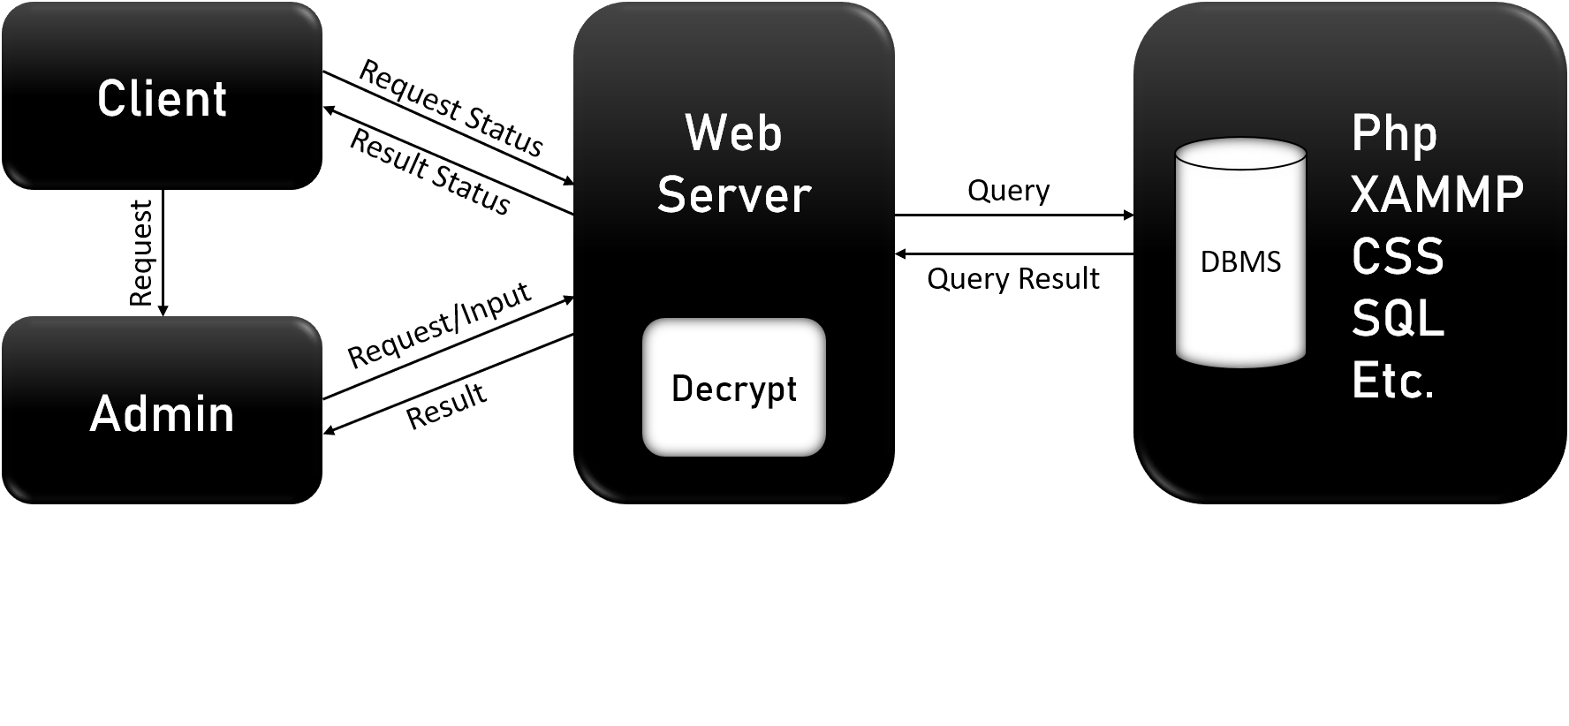

Figure 1 : System Architecture

Graphical representation for the courier management system developed, client gives request through the website and place their choice of order or email to admin or if he/she is an old user they and want to see the package detail they request to the webserver and then it provides the status for the order. The webserver and the website runs on the front end developed on html and css also the backend used to store the database for every shipment detail and every client detail is developed using sql and xammp server.

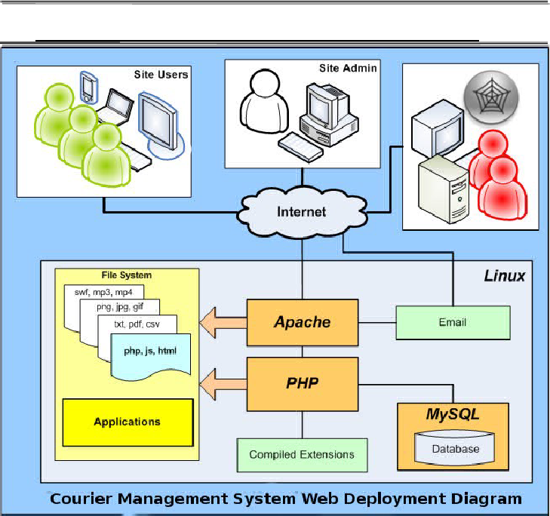

Figure 2 : This is the pictorial representation for the system architecture used in the system

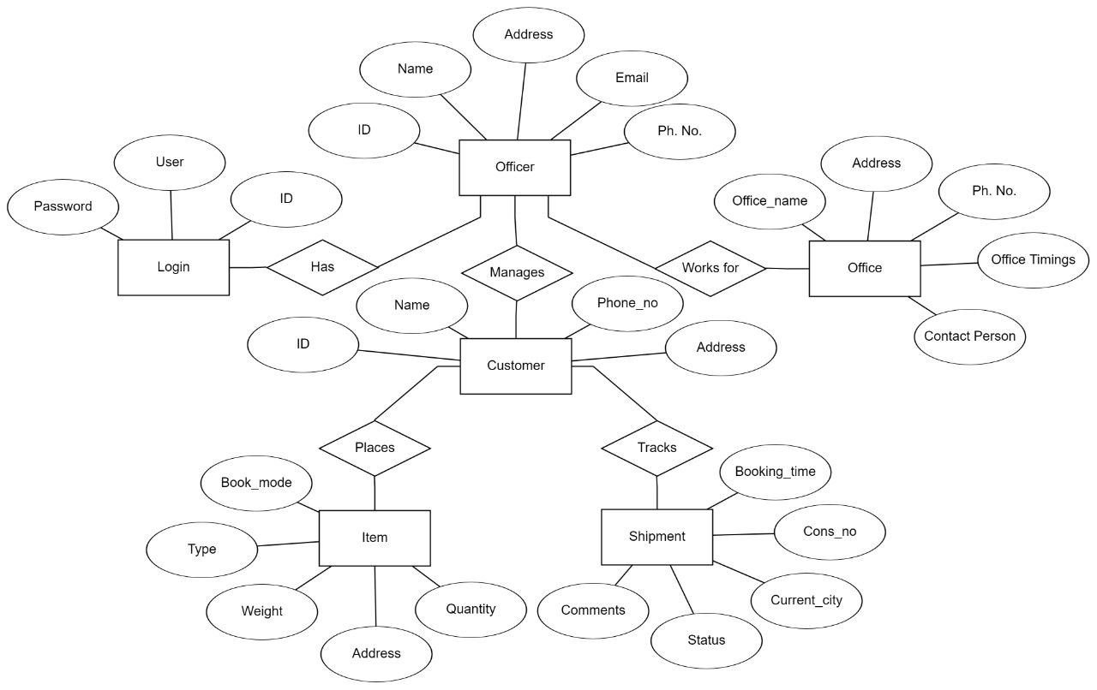

Figure : ER Diagram

ER diagram which is used for depicting the entity, attributes connectivity and dependency on each other.

The relations for this ER-Diagram is represented by officer -> manages(customer)

item -> placed(customer),

officer -> has(login),

customer -> tracks(shipment)

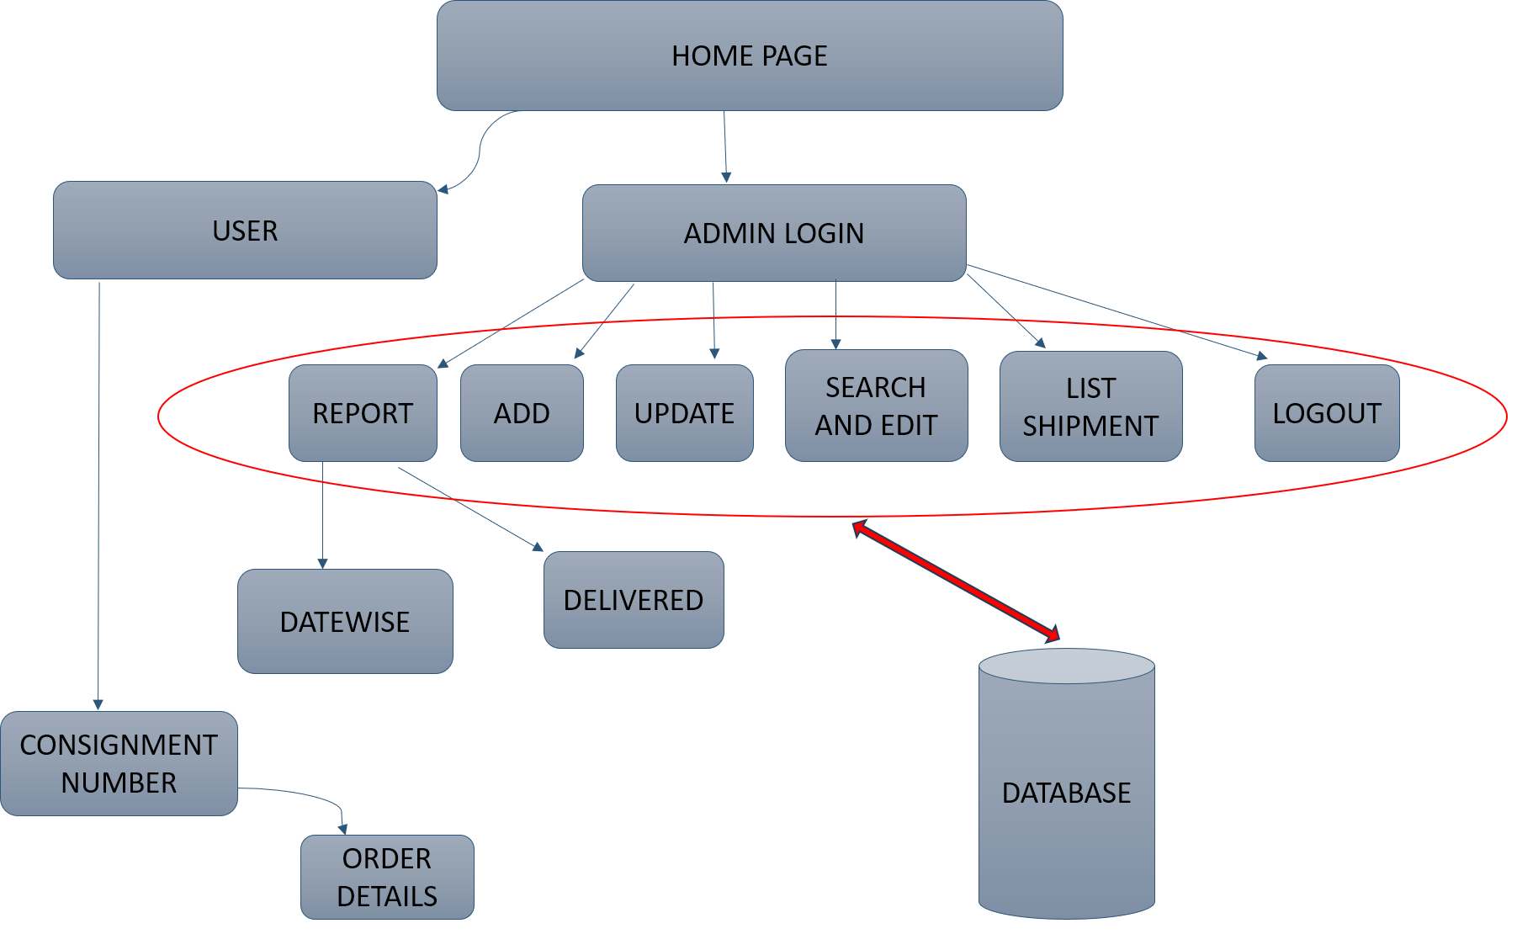

Figure 4 : Functional Architecture

The two modules are assigned to the user and admin, which have different uses according to their needs. Homepage breaks down into two modules user and admin, user only have option to access his/her current or previous order status. Admin having higher authority manages the complete system it has power to access, change and update the report, shipment, search shipment, list shipment. Under report having a sub-module as date wise, delivered all are then linked to database to access the tables built using SQL.

Admin can login into his admin portal.Logging in he/she sends the query to input the details for the new courier to the php webserver.When the query is submitted to the php database admin is updated and the new courier is submitted Customer wants to access the status for the order. He/ she submits the query to the webserver with the details of consignment number and the query is decrypted and goes to php database and then retrieve the correct data and is shown to the customer.

**Modules***–*

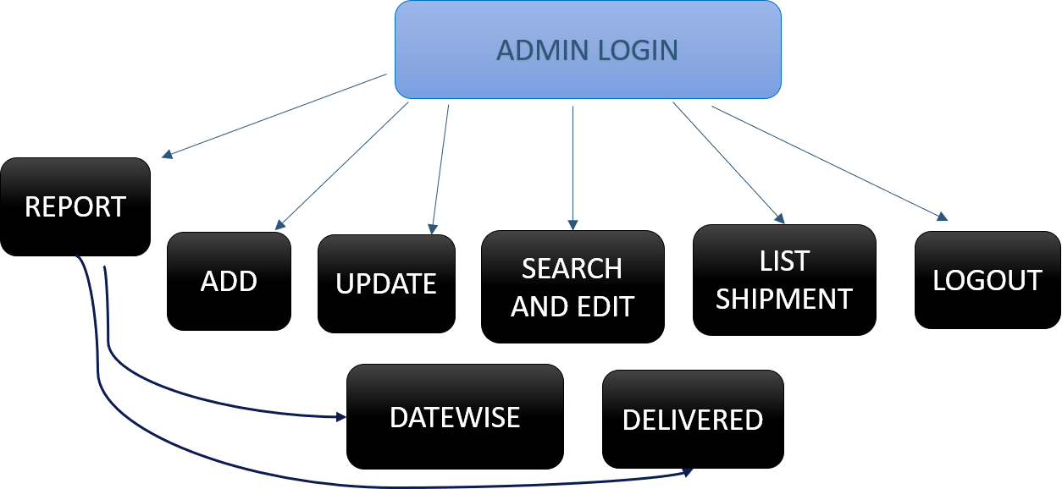

Figure : Admin Module

All the operations listed are performed by the admin to securely and properly run the courier system. Having the options as adding the courier detail for new order by client, updating the order history of previous order and delivered orders, searching and editing the order list for the client convenience, listing all the shipment in an order using the sorting. Going into the report module which is being shown as a sub-module and having the option to view the orders by date wise order and distinguishing them according to their status of delivered or no delivered.

* + - * **Admin module**

In this from figure 5, admin can do the following functions.

(Dashboard : Admin can see all the courier details including pickup date, weight of parcel, destination, delivered couriers etc.)

* + - * Login: Admin can login using user id and password.
      * Add courier: Admin can add courier details as provides by the client.
      * Courier list: Admin can view list of all the couriers.
      * Report
        + Date wise list(undelivered): Shipments sorted date wise.
        + Delivered list: List of delivered couriers.
      * Edit courier: Admin can edit courier details and add comments.
      * Search and edit: Admin can search courier with consignment number.
      * Success (completion)

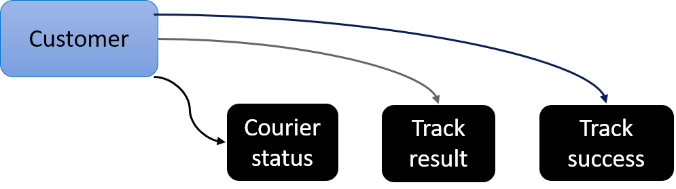

Figure :Customer module

Customer can access all the item listed in black through the check status option on website

* + - * **Customer**

The main aim of this module is providing all the functionality related to customer It tracks all the information of the customer. This is a role-based module where admin can perform each and every operation on data but the customer will be able to view only those access level restrictions has also been implemented on the project. Website provides an interactive user interface to the client.

* + - * Courier status: Client can view the shipment details using consignment number.
      * Track result
      * Track success

All the customer forms are valid on the client side using javascript.

**Innovation** –

* The low-cost system and high usability.
* New secured database with upgradability easiness.
* Due to improvement of technology we see the logistics business to go down and not keep up with the IT industry.
* We present a fast, easy to use, highly secure system for our logistics industry which is almost a trillion dollars industry.

1. **Implementation**

**Software Details –**

* Web Server (XAMMP server)
* PHP: All the business and frontend logic has been implemented in PHP
* HTML: Page layout has been designed in HTML
* CSS: CSS has been used for all the designing part
* JavaScript: All the validation task and animations has been developed by JavaScript
* MYSQL: MYSQL database has been used as database for the project
* Drupal 7: This project has been developed over the Drupal 7 Framework
* Apache2: Project will be run over the Apache2 server

**Required PHP libraries –**

* Curl
* ZIP
* Zlib
* GD library
* Mxrypt
* Mbstrings

**Screenshots –**

**Tables -**

Sql> CREATE table TBL_courier(cid int(10),cons_no varchar(20),ship_name varchar(100),phone int(11),s_add varchar(200),rev_name varchar(100),r_phone varchar(12),r_add varchar(200),type varchar(40),weight double,invice_no varchar(20),qty int(10),book_mode varchar(20),freight double,mode varchar(20),pick_date varchar(20),pick_time varchar(10),status varchar(20),comments varchar(300),book_date date)

*Sql> SELECT * FROM `tbl_courier`*

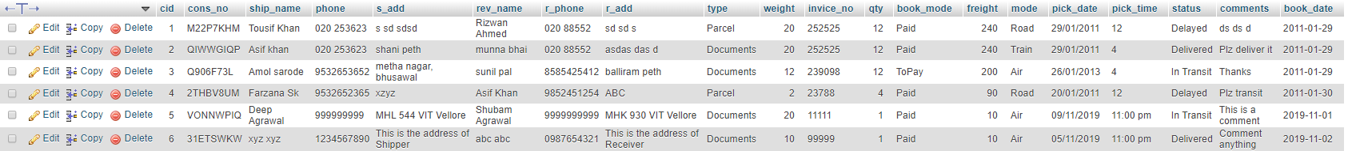

Figure : Courier table containing all details about shipment item.

Sql> CREATE table tbl_officers(id int(10),off_name varchar(100),address varchar(250),email varchar(20), ph_no varchar(20),office varchar(100),reg_date varchar(20))

Sql> SELECT * FROM `tbl_courier_officers`

**

Figure : Officers table containing details of admin including id and password.

Sql> CREATE table tbl_courier_track(id int(10), cons_no varchar(10), current_city varchar(100), status varchar(10), comments varchar(100), bk_time varchar(100))

Sql> *SELECT * FROM `tbl_courier_track`*

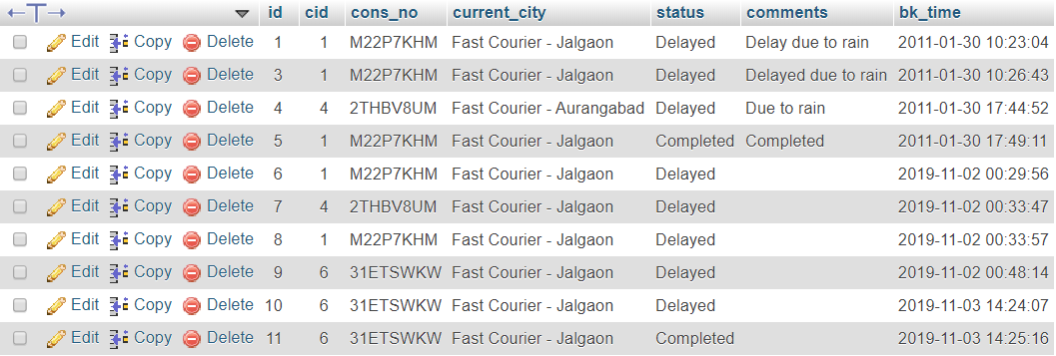

Figure : Track table contains details of shipment including current status.

*Sql>*CREATE TABLE tbl_offices(id int(10), off_name varchar(100), address varchar(100), city varchar(50), ph_no int(10), office_time varchar(100), contact_person varchar(100))

*Sql> SELECT * FROM `tbl_offices`*

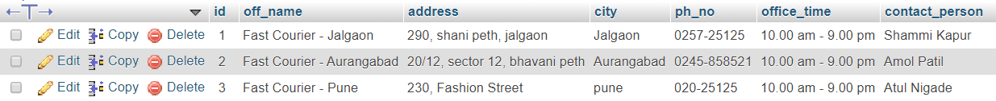

Figure : Offices table contains details about branch of offices.

**Sample Code –**

**Code of main page:**

*<!DOCTYPE html PUBLIC "-//W3C//DTD HTML 4.01 Transitional//EN" "http://www.w3.org/TR/html4/loose.dtd">*

*<html>*

*<head>*

*<meta http-equiv="Content-Type" content="text/html; charset=ISO-8859-1">*

*<title>Online Courier Software Script, Cargo Tracking Module in PHP, MySql in India</title>*

*<meta name="description" content="A Simple Solution to enable Tracking in your Existing Website.">*

*<meta http-equiv="Content-Type" content="text/html; charset=ISO-8859-1">*

*<link rel="stylesheet" href="https://stackpath.bootstrapcdn.com/bootstrap/4.3.1/css/bootstrap.min.css" integrity="sha384-ggOyR0iXCbMQv3Xipma34MD+dH/1fQ784/j6cY/iJTQUOhcWr7x9JvoRxT2MZw1T" crossorigin="anonymous">*

*<script src="https://code.jquery.com/jquery-3.3.1.slim.min.js" integrity="sha384-q8i/X+965DzO0rT7abK41JStQIAqVgRVzpbzo5smXKp4YfRvH+8abtTE1Pi6jizo" crossorigin="anonymous"></script>*

*<script src="https://cdnjs.cloudflare.com/ajax/libs/popper.js/1.14.7/umd/popper.min.js" integrity="sha384-UO2eT0CpHqdSJQ6hJty5KVphtPhzWj9WO1clHTMGa3JDZwrnQq4sF86dIHNDz0W1" crossorigin="anonymous"></script>*

*<script src="https://stackpath.bootstrapcdn.com/bootstrap/4.3.1/js/bootstrap.min.js" integrity="sha384-JjSmVgyd0p3pXB1rRibZUAYoIIy6OrQ6VrjIEaFf/nJGzIxFDsf4x0xIM+B07jRM" crossorigin="anonymous"></script>*

*<link href="new.css" rel="stylesheet">*

*<style type="text/css">*

*</style>*

*</head>*

*<body>*

*<!-- Navigation -->*

*<nav class="navbar navbar-expand-md sticky-top">*

*<div class="container-fluid">*

*<a class="navbar-brand" href="http://localhost/index.php#"><img src="images/logo.png"></a>*

*<button class="navbar-toggler" type="button" data-toggle="collapse" data-target="#navbarResponsive">*

*<span class="navbar-toggler-icon"></span>*

*</button>*

*<div class="collapse navbar-collapse" id="navbarResponsive">*

*<ul class="navbar-nav ml-auto">*

*<li class="nav-item active">*

*<a class="nav-link" href="http://localhost/index.php#">Home</a>*

*</li>*

*<li class="nav-item">*

*<a class="nav-link" href="#about">About</a>*

*</li>*

*<li class="nav-item">*

*<a class="nav-link" href="#connect">Connect</a>*

*</li>*

*<li class="nav-item">*

*<a class="nav-link" href="login.php">Admin Login</a>*

*</li>*

*</ul>*

*</div>*

*</div>*

*</nav>*

*<!--- Image Slider -->*

*<div class="carousel slide" data-ride="carousel" id="slide">*

*<ul class="carousel-indicators">*

*<li data-target="#slide" data-slide-to="0" classs="active"></li>*

*<li data-target="#slide" data-slide-to="1"></li>*

*</ul>*

*<div class="carousel-inner" style="width: 100%; height: 650px !important;">*

*<div class="carousel-item active">*

*<imgsrc="images/1.jpg">*

*<div class="carousel-caption">*

*<button type="button" class="btnbtn-light btn-lg car-btn-1">*

*<a href="track-status.php">Check Status</a>*

*</button>*

*</div>*

*</div>*

*<div class="carousel-item">*

*<imgsrc="images/2.jpg">*

*<div class="carousel-caption">*

*<button type="button" class="btnbtn-light btn-lg car-btn-1">*

*<a href="track-status.php">Check Status</a>*

*</button>*

*</div>*

*</div>*

*</div>*

*<a class="carousel-control-prev" href="#slide" role="button" data-slide="prev">*

*<span class="carousel-control-prev-icon" aria-hidden="true"></span>*

*<span class="sr-only">Previous</span>*

*</a>*

*<a class="carousel-control-next" href="#slide" role="button" data-slide="next">*

*<span class="carousel-control-next-icon" aria-hidden="true"></span>*

*<span class="sr-only">Next</span>*

*</a>*

*</div>*

*<br>*

*<br>*

*<!--- Jumbotron (About) -->*

*<div class="jumbotron" id="about">*

*<div class="container-fluid padding">*

*<div class="row welcome text-center">*

*<div class="col-12">*

*<h1 class="display-4">About</h1>*

*</div>*

*<hr>*

*</div>*

*</div>*

*<div class="col-xs-12 col-sm-12 col-md-9 col-lg-9 col-xl-10">*

*<p class="lead">*

*Mail + Time + Delivery = trust !<br>*

*COURIER MANAGEMENT SYSTEM is one of the most reputed and fast growing courier services to the clients.Our services are widely acknowledge for their features like time saving and very efficient in use.Sending the courier across the internet and no need to visit anywhere.The system is used for daily activities such as booking a courier and track courier etc.*

*<br>*

*A Courier company is one which delivers messages, packages and mail and is known for their speed, security, tracking service and specialisation. Courier services became increasingly popular with the arrival of Internet shopping. Being able to order large and multiple items from online sellers required specialist delivery services that would enable customers to not only receive their items but also enable online sellers to offer things such as next day delivery. Something that is only possible with a courier service.*

*</p>*

*</div>*

*</div>*

*<!--- Connect -->*

*<footer id="connect">*

*<div class="container-fluid padding">*

*<div class="row text-center">*

*<div class="col-md-4">*

*<a class="navbar-brand" href="#"><imgsrc="images/logo.png"></a>*

*<hr class="light">*

*<p>999-999-9999</p>*

*<p>email@gmail.com</p>*

*<p>Dtreet name</p>*

*<p>City, State, 00000</p>*

*</div>*

*<div class="col-md-4">*

*<hr class="light">*

*<h5>Our hours</h5>*

*<hr class="light">*

*<p>Monday: 9am to 5pm</p>*

*<p>Saturday: 10am to 6pm</p>*

*<p>Sunday closed</p>*

*</div>*

*<div class="col-md-4">*

*<hr class="light">*

*<h5>Service Area</h5>*

*<hr class="light">*

*<p>City, State, 00000</p>*

*<p>City, State, 00000</p>*

*<p>City, State, 00000</p>*

*<p>City, State, 00000</p>*

*</div>*

*</div>*

*</div>*

*</footer>*

*</body>*

*</html>*

**Website Screenshot –**

**Home Page:**

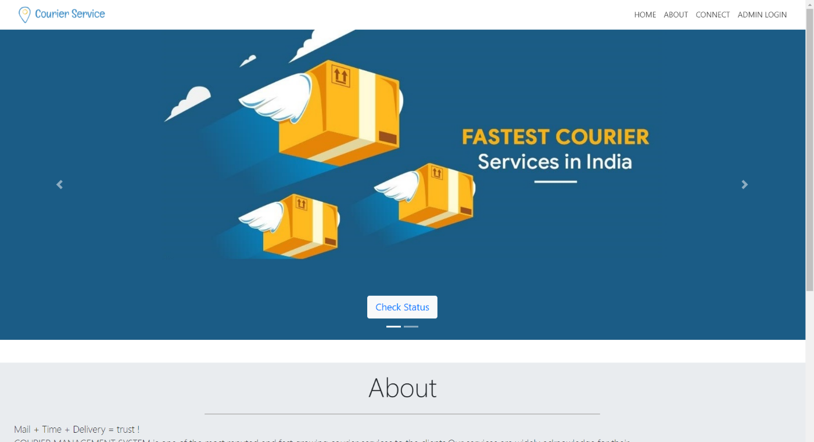

Figure : Home page of website containing Admin login and check status.

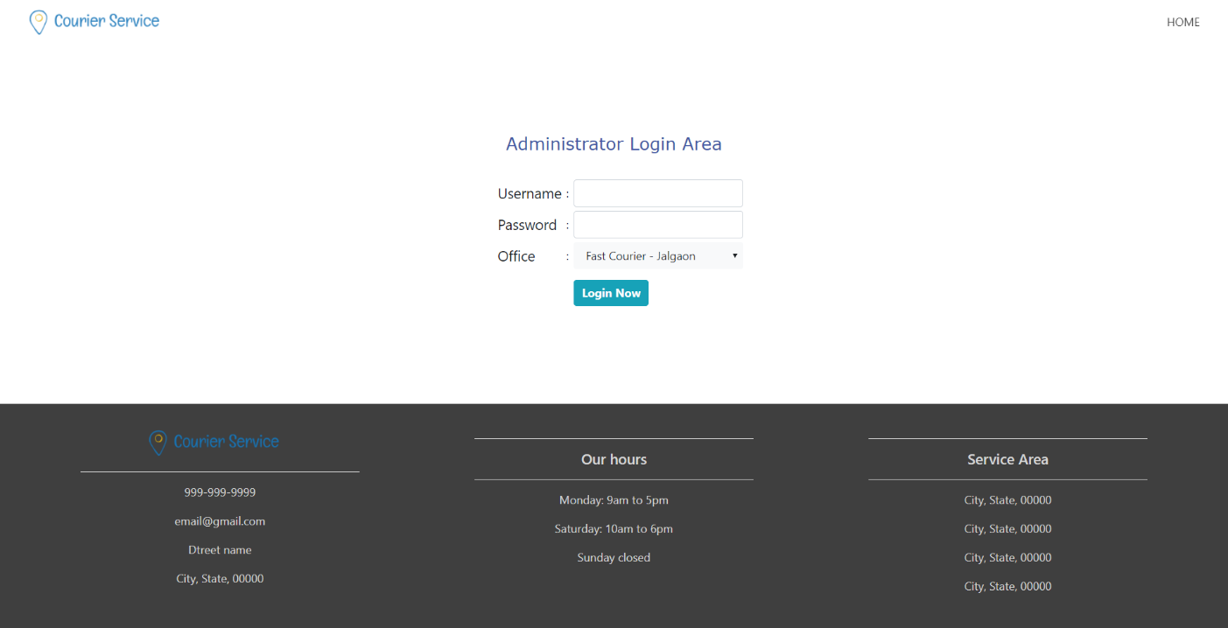

Figure : Login page of admin (to input username and password)

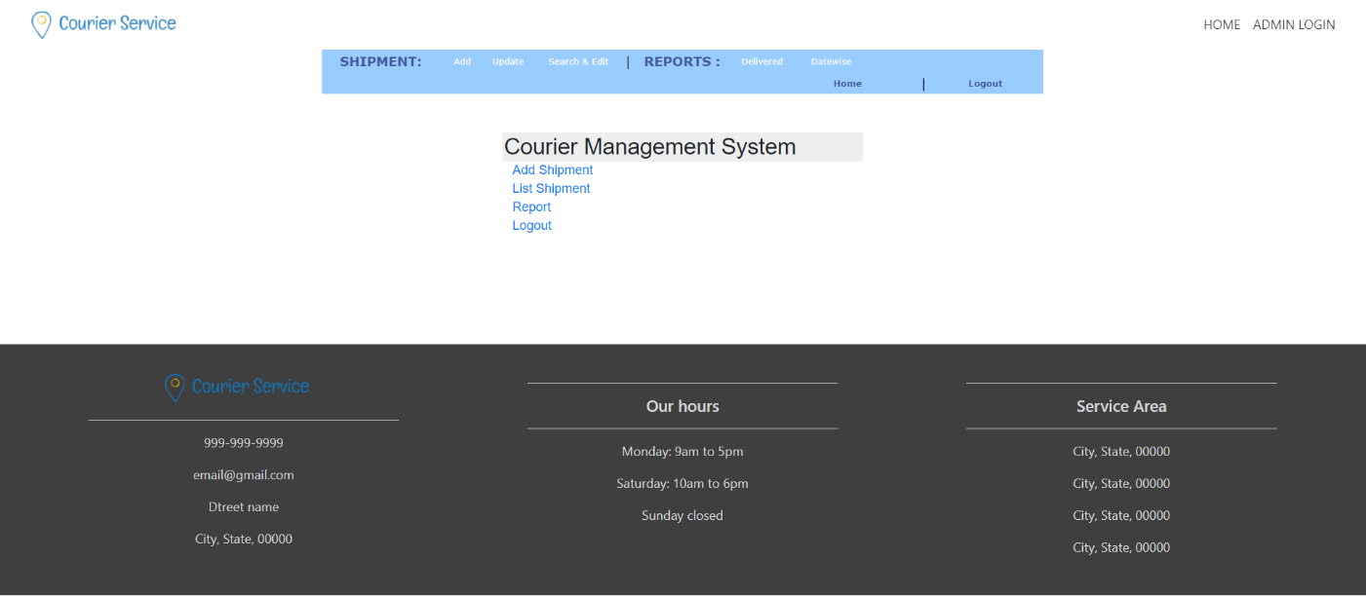

Figure : Options available to admin after login

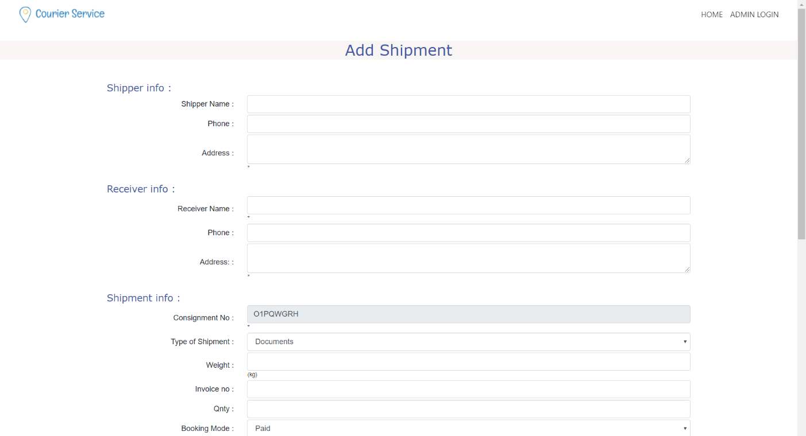

Figure : Web page to add new shipment.

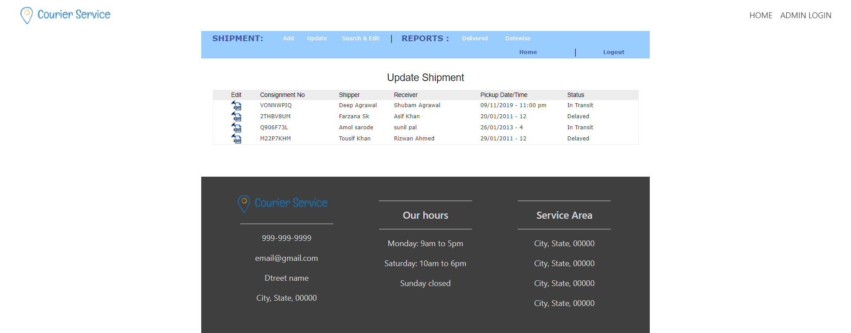

Figure : List of all shipments and link to update shipment details.

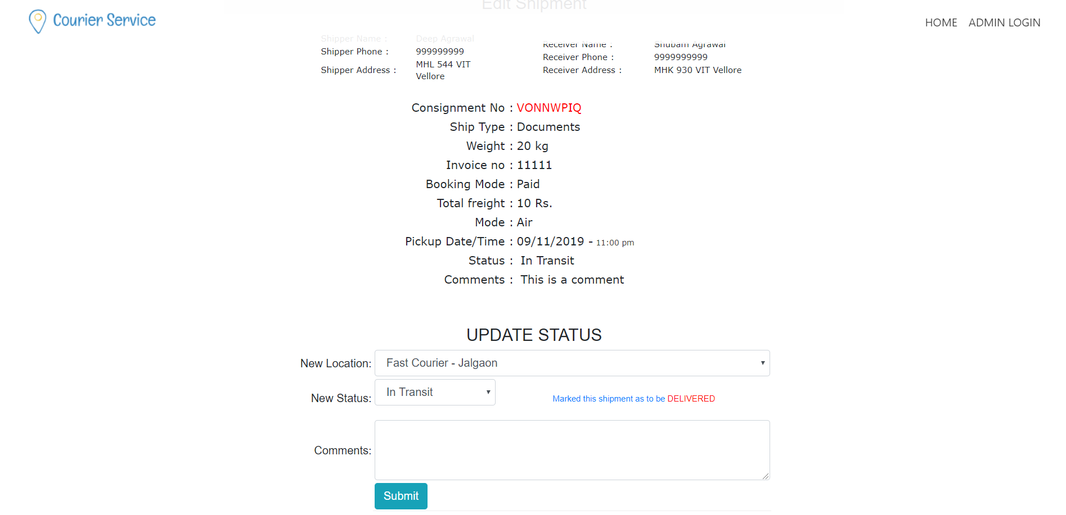

Figure : Update shipment current status and option to mark it as delivered.

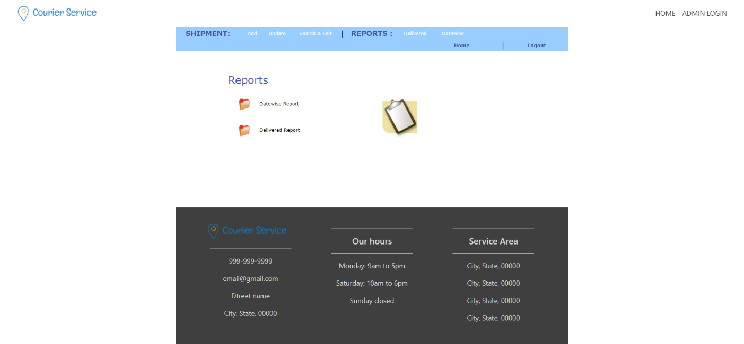

Figure : Shipments sorted date wise and list of delivered couriers.

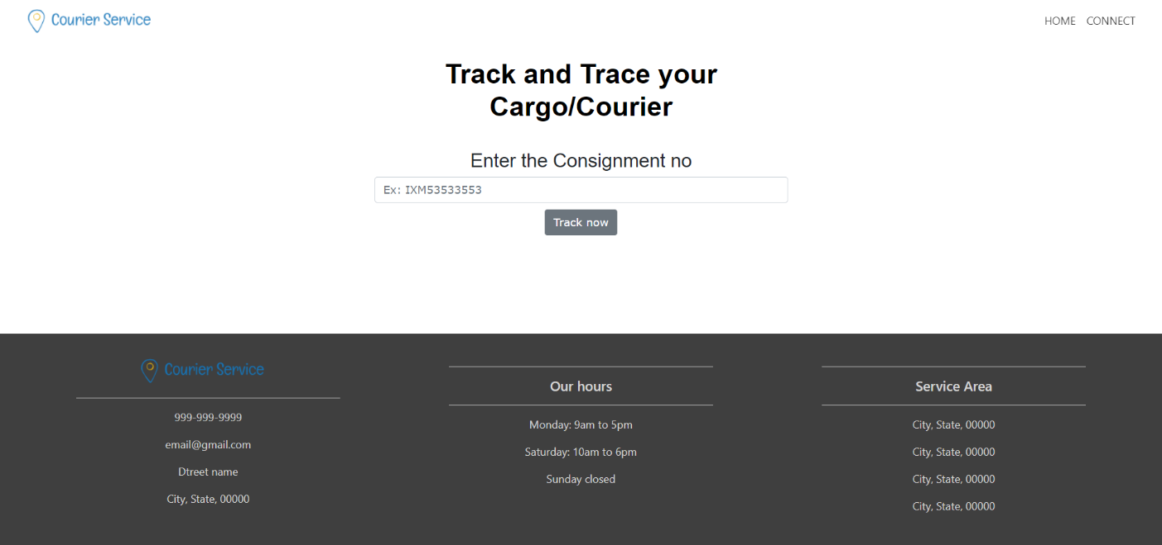

Figure : Client can check shipment details using consignment number.

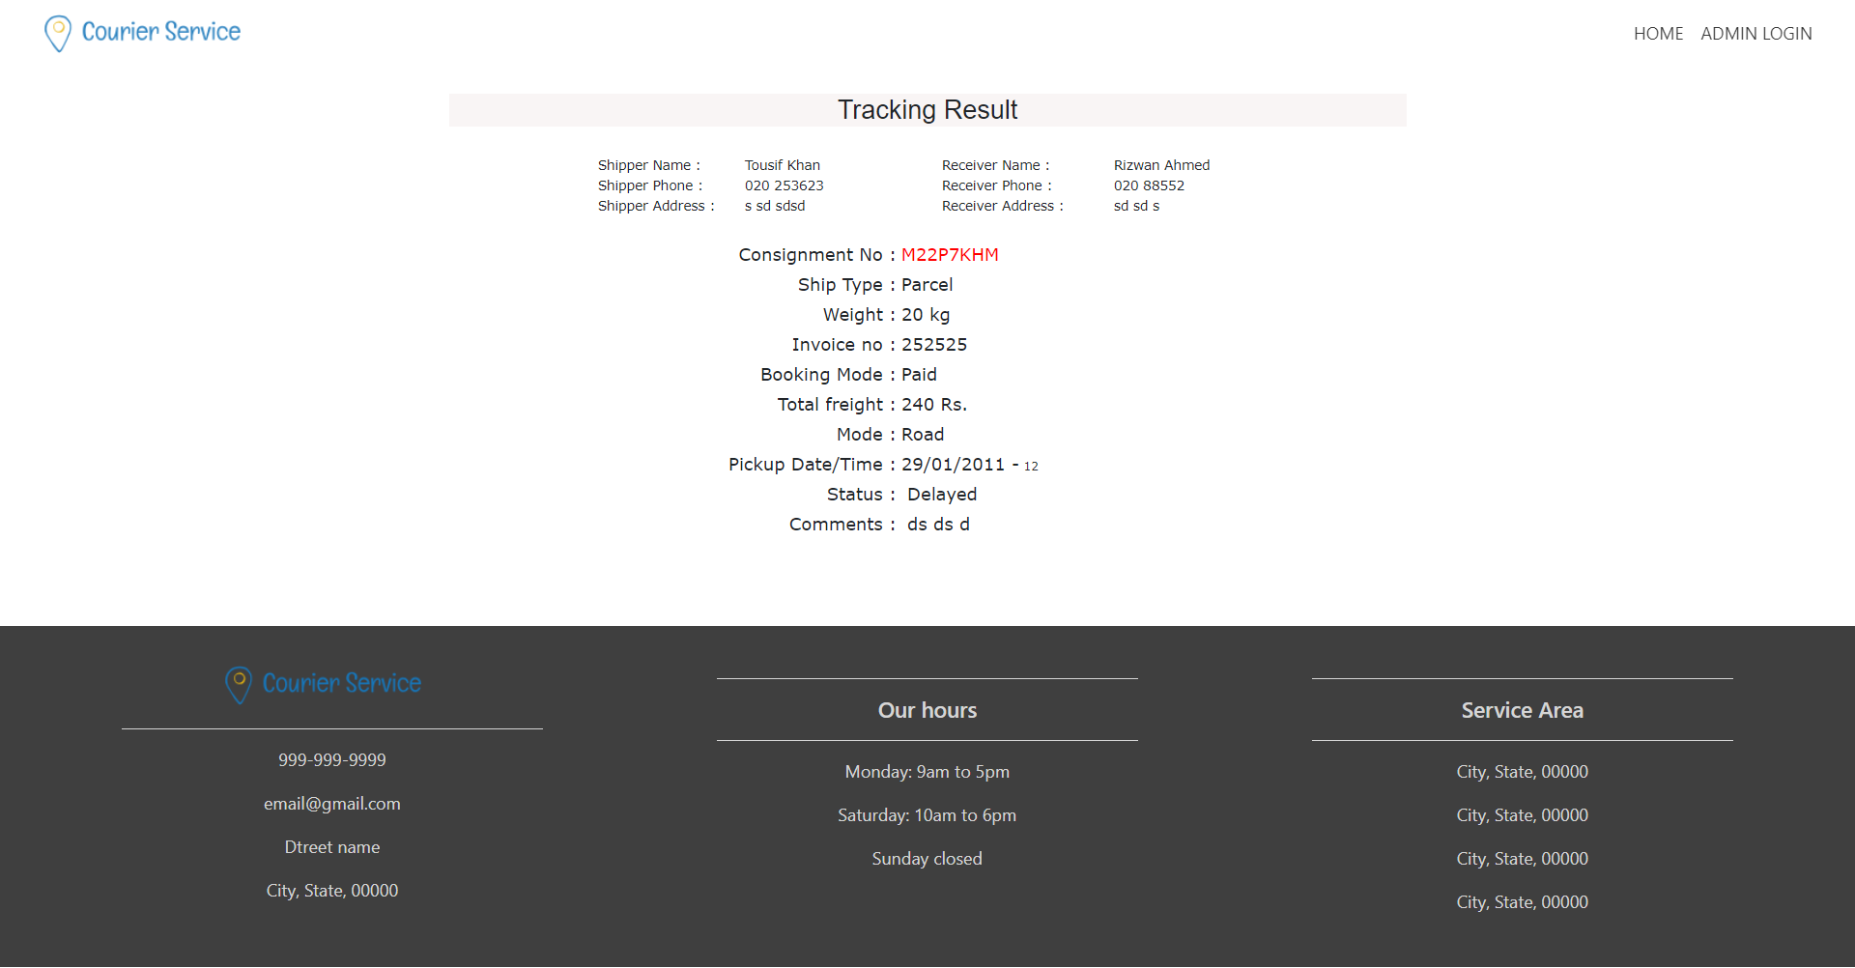

Figure : These are all the details shown to the client on tracking using consignment number.

1. **Conclusion**

The project Courier Management System (HMS) is for computerizing the working in a courier company. The software takes care of all the requirements of an average courier system and is capable to provide easy and effective storage of information related to shipments provided by the client and regular update in current status of the courier location.

It generates reports; provide prescription details including current status and sort the courier date wise to prioritize the delivery of delayed shipments. The Courier website have a modern look and interface making much easier for the client to check the courier status anytime anywhere using internet.

1. **References**

[1] <https://phpgurukul.com/courier-management-system-using-php-and-mysql/>

[2] Aaron ( 2008). “ Relevance of courier services” Tamaza Publishing Co. Ltd., Zaria-Nigeria.

[3] Carola (2012). “Building the Business Case for e-Delivery,” Retrieved on September 22, 2013, from [www.elearningguild.com](http://www.elearningguild.com).

[4] Collins English Dictionary - Complete & Unabridged 10th Edition 2009 © William Collins Sons & Co. Ltd. McGuigan (2013).

[5] "Messengers in the County of Artois, 1295-1329". Canadian Journal of History 25 (2): 163–175.

[6] <http://www.bluedart.com/>

[7] http://www.wampserver.com/en/

[8] http://www.php.net/

[9] http://www.tutorialspoint.com/mysql/

[10] httpd.apache.org/docs/2.0/misc/tutorials.html